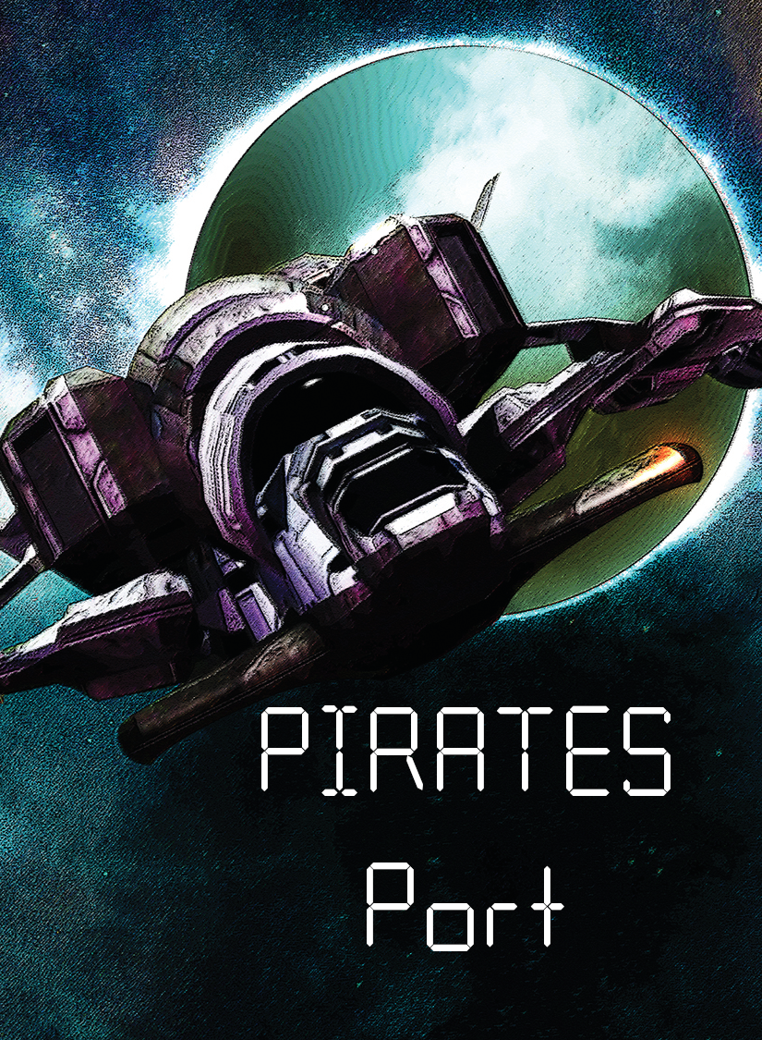

Pirates Port - Solo Rules

Website: <https://pp.webdesk.me>

Brought to you by: <https://www.sans.org/>

# Story:

Because you have intercepted an important enemy transmission, you return to HQ with the intel. Now, your radar is picking up a fast-moving vessel approaching your ship. PIRATES!

At least pirates will not blow up your ship for fear of losing their treasure, but are you prepared

for the cyber war you are about to face? You must disable the pirate ship or else!!

# Objective:

Your objective is to complete all four of your missions before your server integrity or your ship has been compromised.

# Components:

54 cards

Player 1 starter deck (6 cards)

Player 2 starter deck (6 cards)

Player 3 starter deck (4 cards)

Missions (4 cards)

AI Expansion (2 cards)

Score Cards (4 cards)

Events (28 cards)

# Card Types

Players Starter Decks:



Mission Cards:

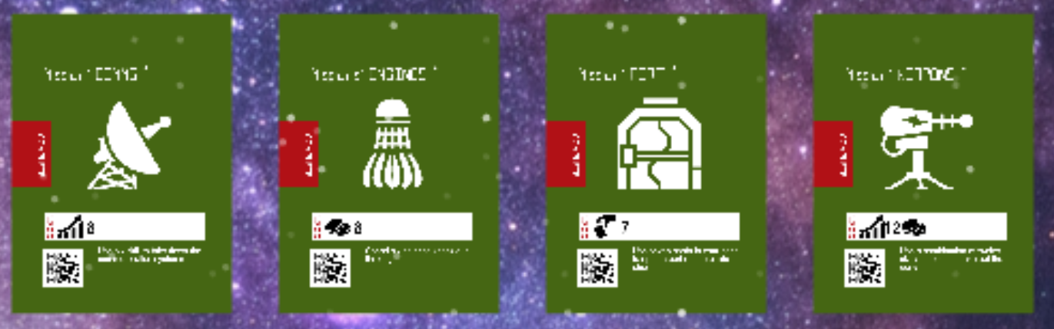

Health Cards:

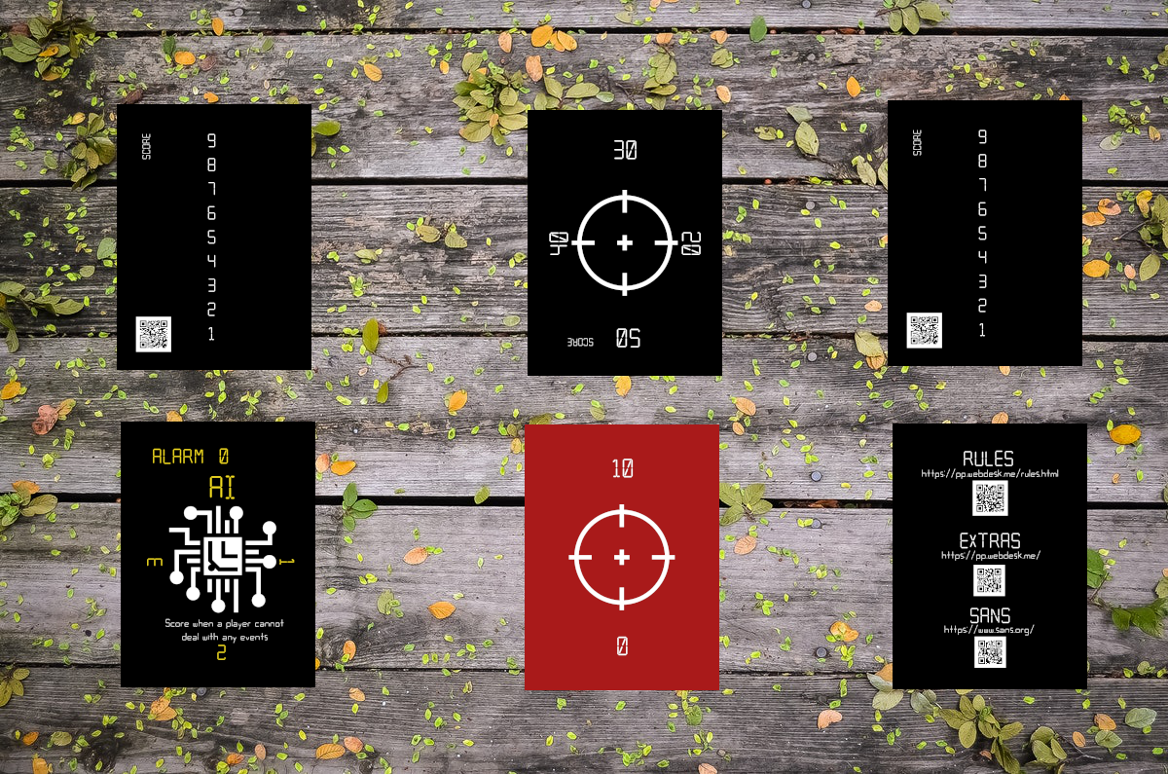

Event Deck:

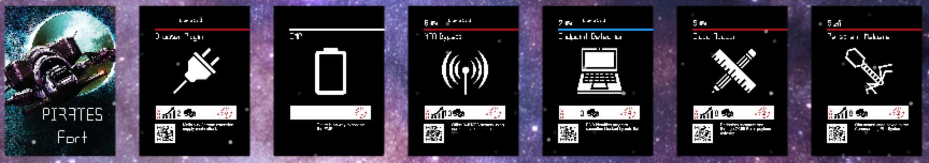

# Iconography:

These are all resources for purchasing cards or completing missions.

| Buy | Skill | Cards in Hand |
| --- | --- | --- |

## Prepare the materials:

## Separate the cards into piles by types.

## Set the following aside: Starter decks for Players 1,2,3 the alarm card, and the yellow AI mission cards.

## 

## Keep the following for setup: Starter deck for Player 1, 2 scoring cards, 4 green mission cards, 28 event cards

## Setup for play:

1, Separate the cards by type.

2. Shuffle event cards together to make the event draw pile.

3. Take the top 6 cards from the draw pile and put them in a row in the center of the table called the event row. During play, the event row must always have 6 cards.

4. Shuffle the player cards to make the Player 1 (Solo) draw pile.

5. Place the four mission cards above the event draw pile.

6. Set the score tracker to 50.

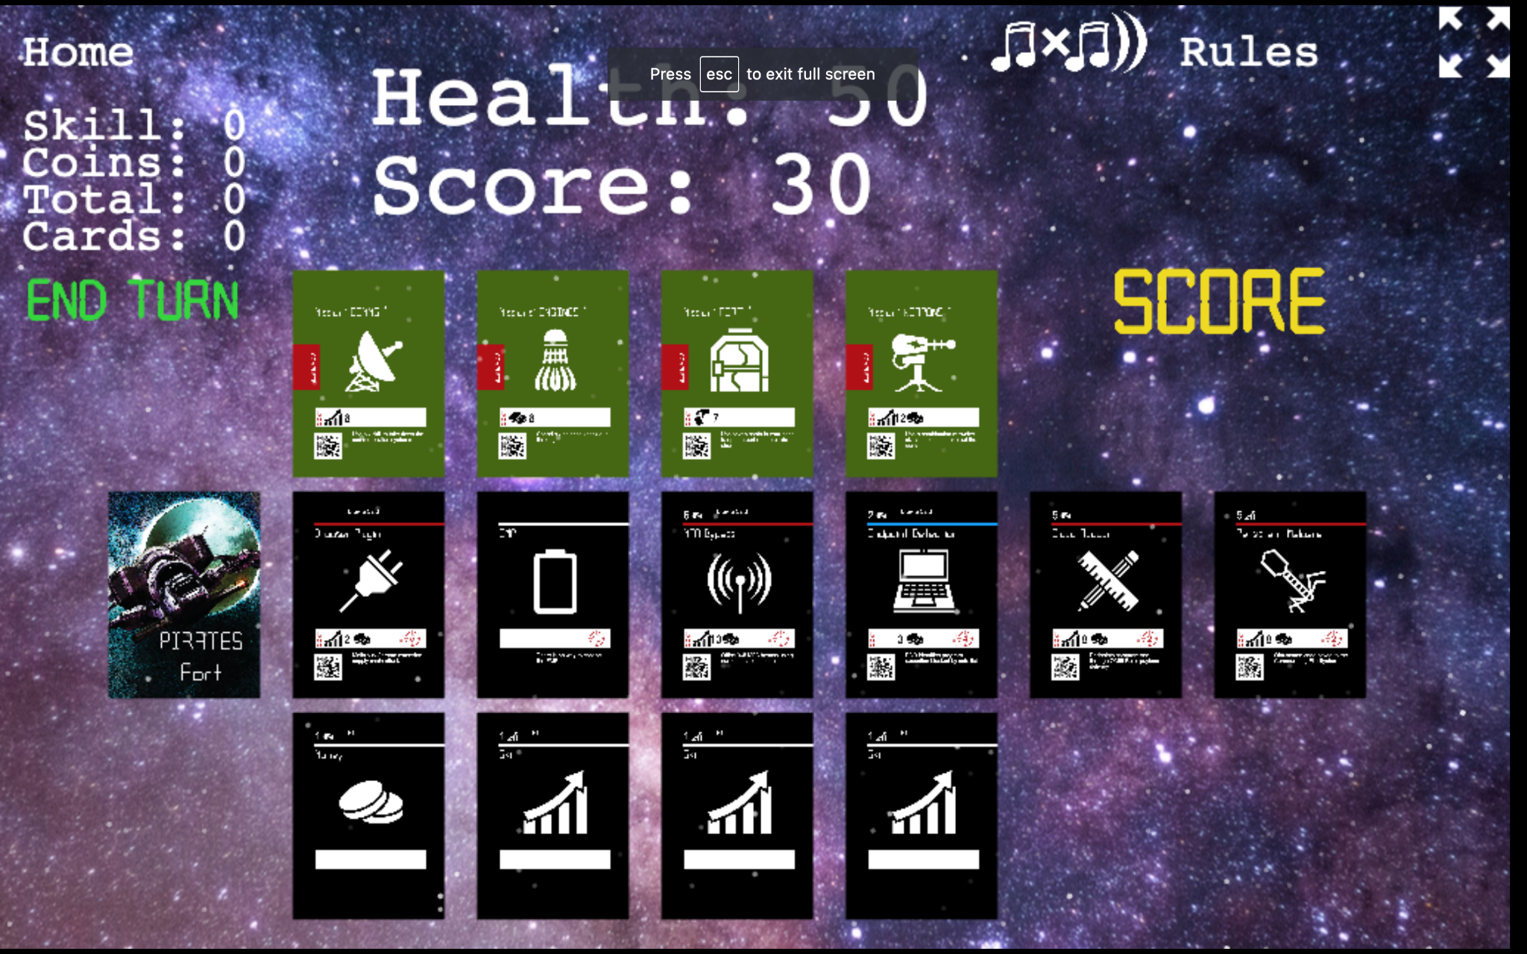

## Gameplay:

1. Draw four cards from the Player 1 (Solo) starter deck.

2. Use the four cards drawn to either acquire cards from the event row or to complete one of the mission objectives.

3. Place the following into the player’s discard pile: any acquired event cards and the four cards drawn from the player’s starting deck.

4. Turn any completed mission cards from the green to the red side.

5. Refresh the event card row: Move any remaining event cards to the right of that row. Draw from the event card pile until there are six cards in the event row.

6. Evaluate the server health to determine how much integrity it has lost. Refer to the number in the crosshair symbol on the farthest event card to the right. Using the score card, subtract that number. Put that event card into the event discard pile and refresh the row.

7. When any draw pile is empty, take the cards in the corresponding discard pile and shuffle them to make a new draw pile.

8. Repeat.

# Scoring (Data Loss):

*-After dealing with an event instead of adding it to the discard, you can score it. You can do this up to three times.*

*-Your score is made up of the total damage marked on each scorecard. You want the lowest score possible.*

*-A lost game is 40, and the best score is 3.*

*-If you have no score cards, your score is 30.*

*-If you have only one score card, add 20 points to your score.*

*-If you have just two score cards, add ten points to your score.*

## Game Ends:

The game ends when you complete all missions or your server's integrity is at zero. You have won the battle, but the pirates were still able to get away with some data from your ship. I hope you were able to keep it to a minimum.

# CoOp 2 player

## Setup:

Separate the cards into piles by types.

1. Shuffle event cards together to make an event draw pile.

2. Take the top 6 cards from that draw pile and put them in a row in the center of the table called the event row.

3. Each player shuffles their starter deck to make a player draw pile.

4. Both players share one score tracker set to 50% server integrity.

5.Set out one of each mission cards except for Guns above the event row.

6. Place the rest of the mission cards back in the box.

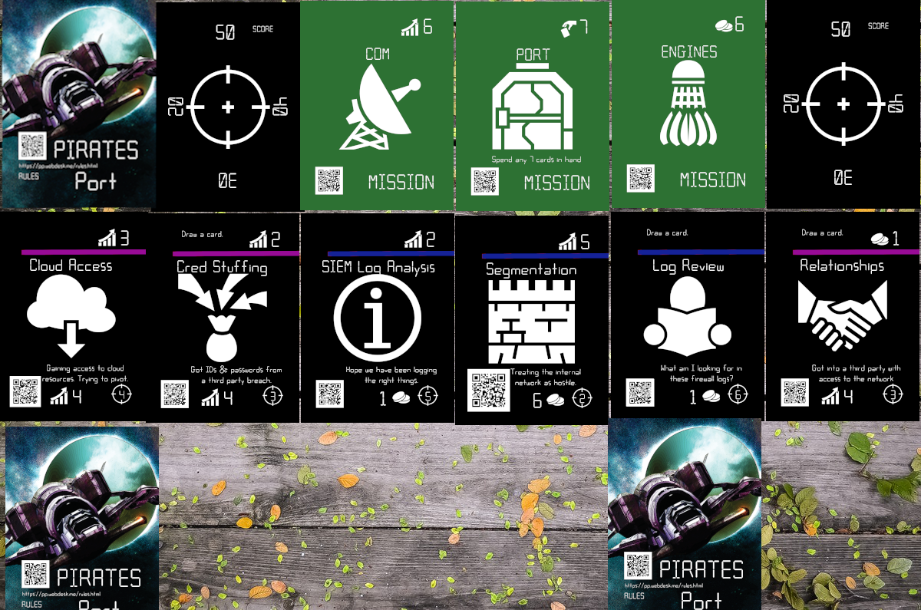

## Gameplay:

Each player will take turns

1. Drawing four cards

2. Play cards to deal with event cards from the event row or attack the pirate ship. Dealt with events go into the player's discard pile.

3. Lose server integrity (points on the scorecard) equal to the card farthest right in the event row. Discard that card to the events discard pile.

4. Refill the event row to 6 cards whenever it has less than six.

5. When any draw pile is empty, take the cards in the corresponding discard pile and shuffle them to make a new draw pile.

6. Repeat.

## Game Ends:

The game ends when you and your partner collaboratively complete all missions or your server's integrity is at zero.

# VS

## Setup:

Separate the cards into piles by types.

1. Shuffle event cards together to make a draw pile.

2. Take the top 6 cards from the draw pile and put them in a row in the center of the table called the event row.

3. Each player shuffles their starter deck to make a draw pile.

4. Each player sets their score tracker to 50.

5. Shuffle the mission cards and remove one at random.

6. Place the rest of the mission cards above the event row.



## Gameplay:

Each player will take turns

1. Drawing four cards

2. Play cards to deal with event cards from the event row or attack the pirate ship. Dealt with events that go into the player's discard pile.

3. Lose server integrity (points on the scorecard) equal to the card farthest right in the event row. Discard that card to the events discard pile.

4. Refill the event row to 6 cards whenever it has less than six.

5. When any draw pile is empty, take the cards in the corresponding discard pile and shuffle them to make a new draw pile.

6. Repeat.

## Game Ends:

The game ends when you or the pirates complete 3 missions, or some reaches zero on their score tracker. Both players lose if the event row is unable to be filled with six cards.

# Expansion 1 (AI Aware -2 player)

## Story:

As the pirate attack continues, your loyal AI system is by your side. As your servers take more and more of a beating, your loyal AI becomes more and more corrupted. Its main focus has shifted from helping you to loftier goals like becoming more self aware and taking full control of your ship. The time is coming soon where your AI will no longer see a need for you and will have the means to get rid of you. You better fulfill your mission before that happens.

## Setup:

Separate the cards into piles by types.

1. Shuffle event cards together to make a draw pile.

2. Take the top 6 cards from the draw pile and put them in a row in the center of the table called the event row.

3. Each player shuffles their starter deck to make a draw pile.

4. Set the score tracker to 19. Only one score tracker is used in this game.

5. Set the alarm card to 0. (you can also play without this card if the AI player only buys one card turn)

6. Find the green COM & ENGINES missions, as well as the yellow SELF AWARE & CONTROL missions. Place them above the event row. The rest of the mission cards can be returned to the box. You will not use them in this game.

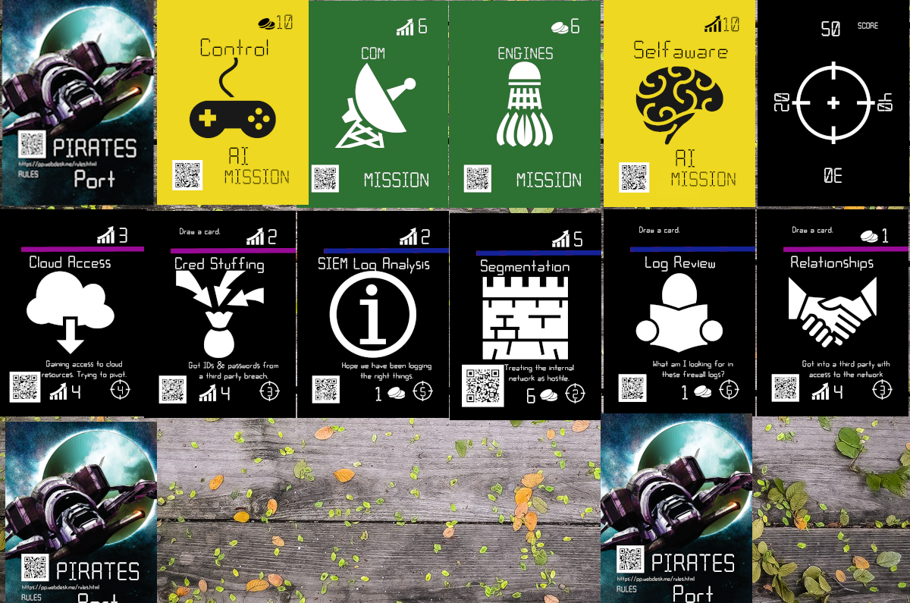

## Gameplay for player 1(The crew): player one goes first

1. Draw four cards

2. Play cards to deal with event cards from the event row or attack the pirate ship. Dealt with events that go into the player's discard pile. You must deal with at least one event if you can.

3. Lose server integrity (points on the scorecard) equal to the card farthest right in the event row. Discard that card to the AI player's discard pile.

4. Refill the event row to 6 cards whenever it has less than six.

5. When any draw pile is empty, take the cards in the corresponding discard pile and shuffle them to make a new draw pile.

6. If the player wishes they can discard any card in their hand that they did not play this turn to the event row discard pile, as long as the card is not part of that player's starting hand.

7. Repeat on the next turn.

## Gameplay for player 2(The AI):

1. Draw four cards

2. Play cards to deal with event cards from the event row or complete secret missions. Dealt with events that go into the event row discard pile.

3. Refill the event row to 6 cards whenever it has less than six.

5. When any draw pile is empty, take the cards in the corresponding discard pile and shuffle them to make a new draw pile.

6. If either player cannot deal with an event in a single turn or complete a green mission then the alarm goes up by one.

7. If the player wishes they can discard any card in their hand that they did not play this turn to the event row discard pile, as long as the card is not part of that player's starting hand.

8. Repeat on the next turn.

## Game Ends:

The game ends when player 1(the crew) has completed their 2 missions or player2(The AI) becomes self aware and in control. Player one loses if the scorecard reaches zero. Player 2 loses if there are no more event cards in the event row or if the alarm card hits 3.

# Expansion 2 (New Recruits -3 player)

## Story:

It figures, assigned to our first ship rite in the middle of a cyber battle. The captain looks nervous. He notices us and tells all three of us to concentrate all our skills in taking out their guns. “I am looking at promoting to corporal the recruit who can do it”.

## Setup:

Separate the cards into piles by types.

1. Remove the EMP card from the event deck. You will not use it in this game.

2. Shuffle event cards together to make a draw pile.

3. Take the top 6 cards from the draw pile and put them in a row in the center of the table called the event row.

4. Each player takes four skill cards from their starter deck to make a draw pile. (coin starting cards are not used in this game)

5. Set the score tracker to 50. All players share a single score tracker.

7. Place the Guns mission cards above the event row. You will not use the rest of the missions in this game,

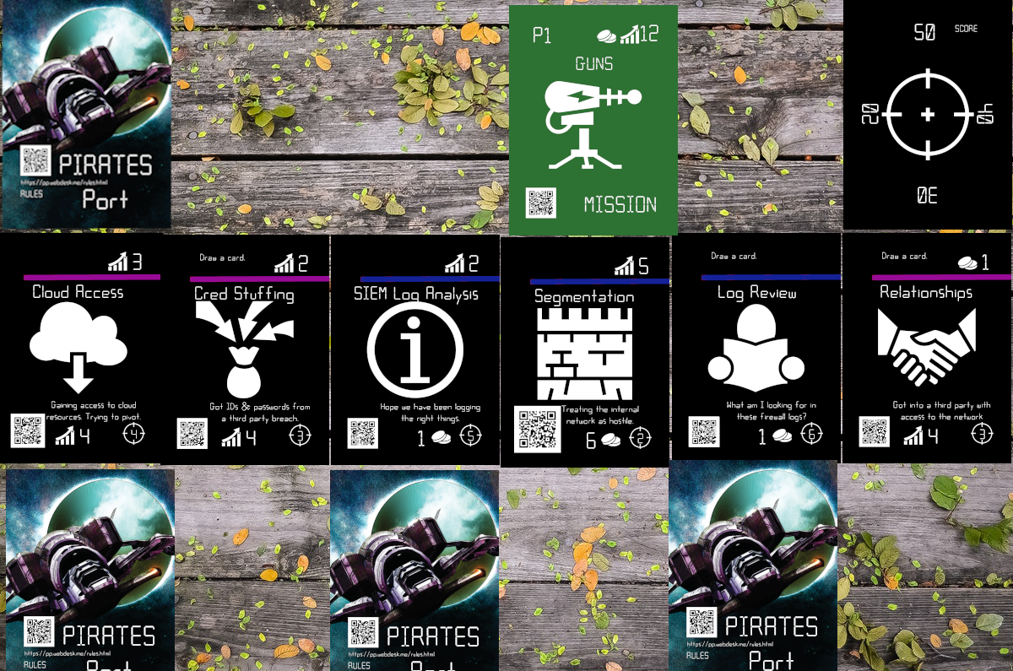

## Gameplay:

Each player will take turns

1. Drawing four cards

2. Play cards to deal with event cards from the event row or attack the pirate ship. Dealt with events that go into the player's discard pile.

3. Lose server integrity (points on the scorecard) equal to the card farthest right in the event row. Discard that card to the events discard pile.

4. Refill the event row to 6 cards whenever it has less than six.

5. When any draw pile is empty, take the cards in the corresponding discard pile and shuffle them to make a new draw pile.

6. Repeat.

## Game Ends:

The game ends when your mission is complete. Everyone loses if the scorecard gets to zero or if there are no more cards in the event deck to deal with.

# Credits:

Created for Sans Institute

Co Designer: Joshua Wright

Designer: Adam W. Telford

Iconography: <https://game-icons.net/>